
Department of Computer Science
AICT Lab 1st Semester Final Project
Project Title:
Online Restaurant
Group Members:
- Waleed Mahmood (2025-CS-181)
- Musab Hussnain (2025-CS-206)
- Abdul Hadi (2025-CS-218)
- Dawood Mahmood (2025-CS-184)
- Nahyaan Mustafa (2025-CS-205)
Course:
AICT (Application of Information and Communication Technology)
Instructor:
Mam Ramsha Khalid
Teaching Assistant:
Sir Usman Ashfaq
Date:
05 January 2026

Table of Contents

Summary & Objectives: 3
Site Structure and Navigation 3
Design Choices 4
Screenshots 4
Website Snippets 6
Home Page: 6
About Page: 6
Menu Page: 7
Gallery Page: 7
Contact Page: 8
Live Website Link: 8
How to run website? 8
Reflections (What was learned, improvements) 8

Summary & Objectives:
Summary
The Online Restaurant project is designed to provide a modern digital platform where customers can conveniently explore restaurant services, view menu offerings, and interact with the business online. The website aims to enhance customer engagement by presenting clear navigation, visually appealing design, and accessible information. Through this project, we implemented core web technologies including HTML and CSS to develop a responsive and user-friendly website. The project also emphasizes the importance of documentation, data organization, and version control. Overall, this project reflects our understanding of website development workflows and demonstrates how digital solutions can improve restaurant visibility and customer experience.
Objectives
- To design a responsive online restaurant website using HTML and CSS
- To create a user-friendly and attractive web interface
- To display restaurant menu and information clearly
- To ensure the website works on desktop, tablet, and mobile devices
- To apply basic web design and responsive layout techniques
Scope
- The project focuses on front-end development using HTML and CSS
- Includes static pages such as Home, Menu, About Us, and Contact
- Allows users to view food items and prices
- Responsive design using media queries, Flexbox, or Grid
- Does not include backend features like ordering, payment, or database

Site Structure and Navigation
- The website follows a clear and organized structure to ensure ease of use for visitors.
- A responsive navigation bar is implemented, allowing users to access all pages from any section of the website.
- The website consists of multiple static pages including Home, About Us, Menu, Gallery, and Contact.
- The Home page provides an introduction and highlights of the restaurant.
- The About Us page presents background information about the restaurant.
- The Menu page displays food items, categories, and prices in a well-organized layout.
- The Gallery page showcases food images to visually attract customers.
- The Contact page contains essential details such as address, phone number, and email.
- Consistent layout and design are maintained across all pages for a uniform user experience.
- Navigation links are clearly labeled, making it easy for users to move between pages without confusion.

Design Choices
- A sans-serif font (such as Poppins or Arial) is used to improve readability and give the website a modern look.
- The color scheme is based on a food-themed palette, using red and orange as primary colors to attract user attention and stimulate appetite.
- White and light gray are used as secondary colors to maintain balance and visual clarity.
- The website layout is kept clean and well-spaced to avoid clutter and improve user experience.
- Consistent fonts, colors, and spacing are maintained across all pages for a uniform design.
- The design is responsive, ensuring proper display on desktop, tablet, and mobile devices.
- Images are carefully selected and optimized to enhance visual appeal without affecting performance.
- Simple and intuitive design elements are used to make navigation easy for users.
- Icons (such as Font Awesome icons) are included to improve visual understanding and interface quality.

Screenshots

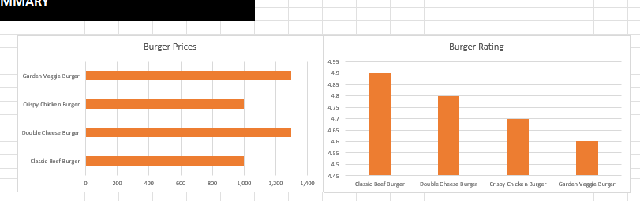
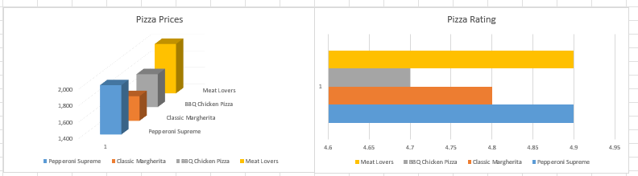

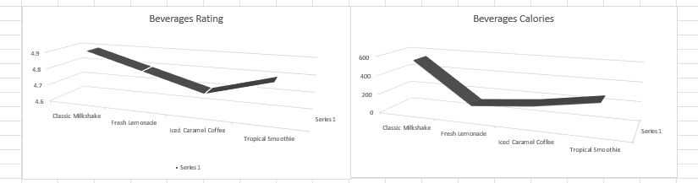

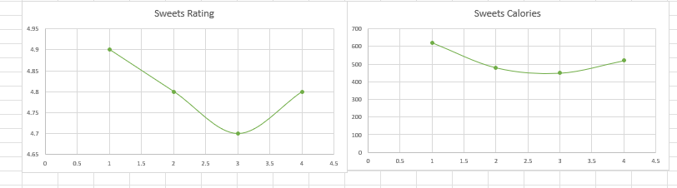

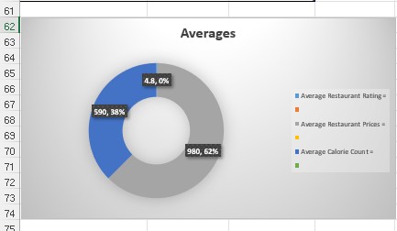

Website Snippets

Home Page:
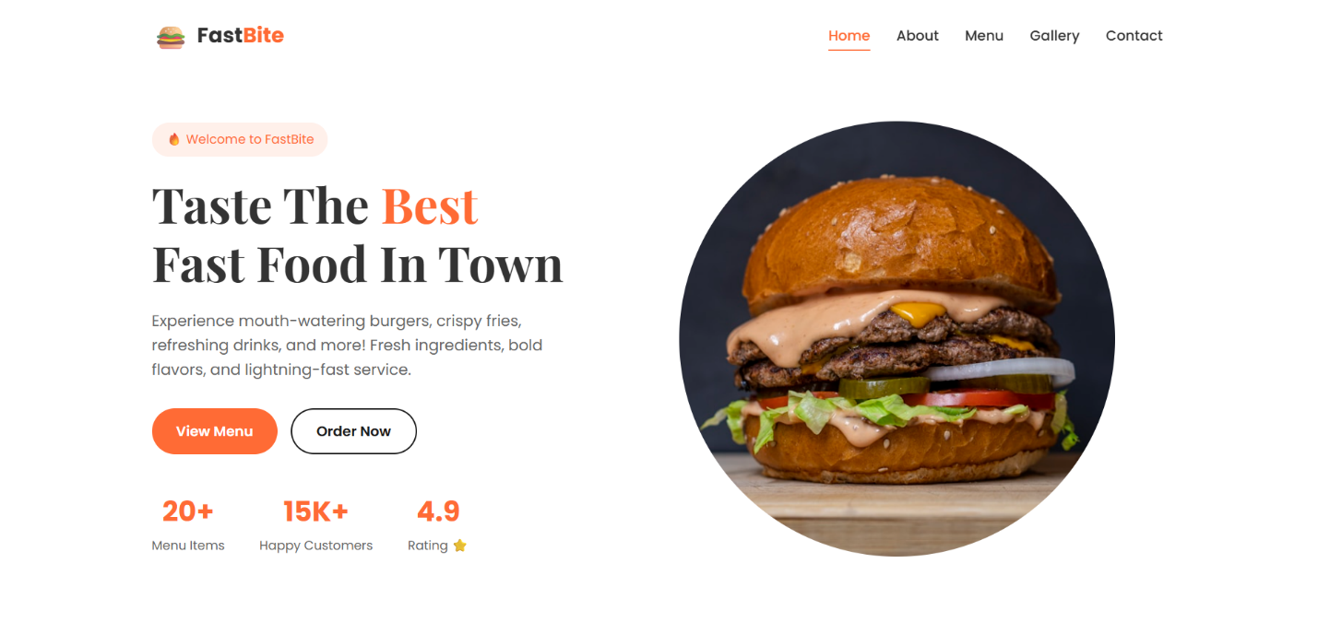

About Page:
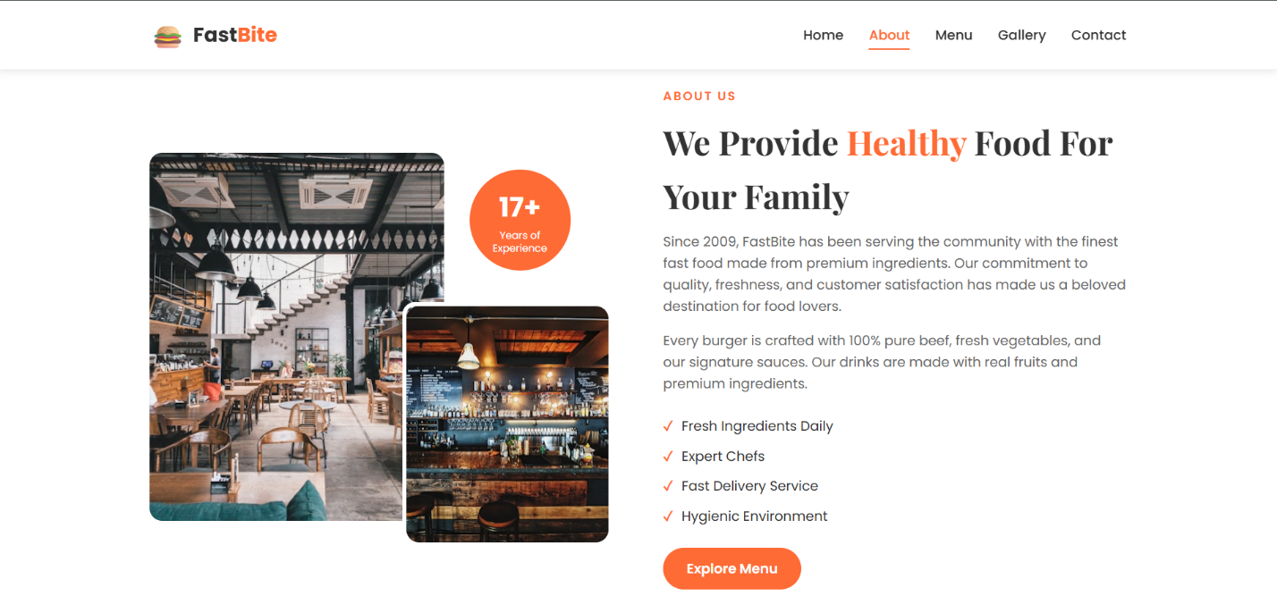

Menu Page:
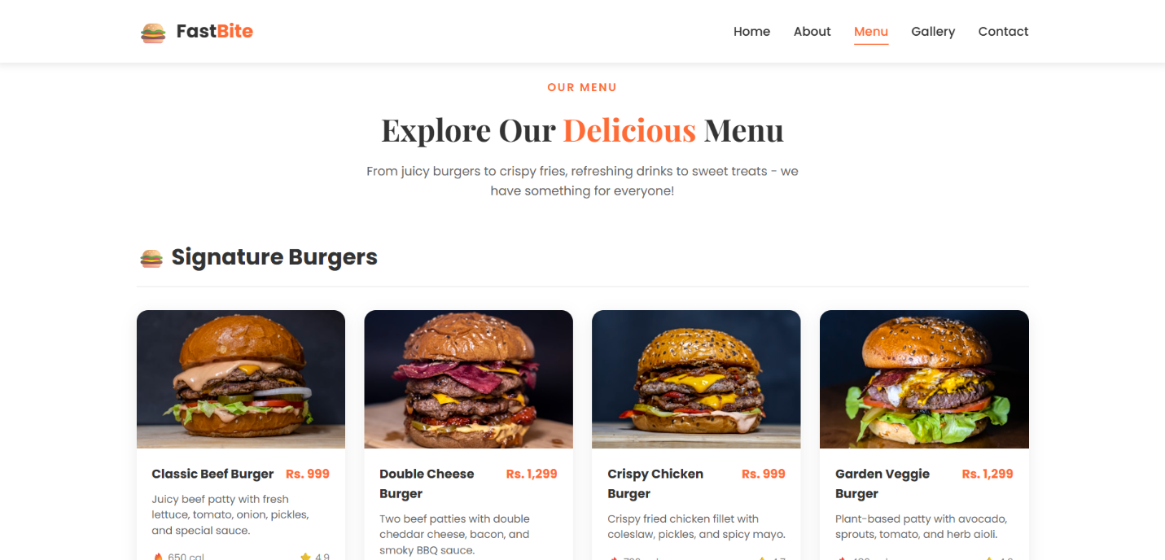

Gallery Page:
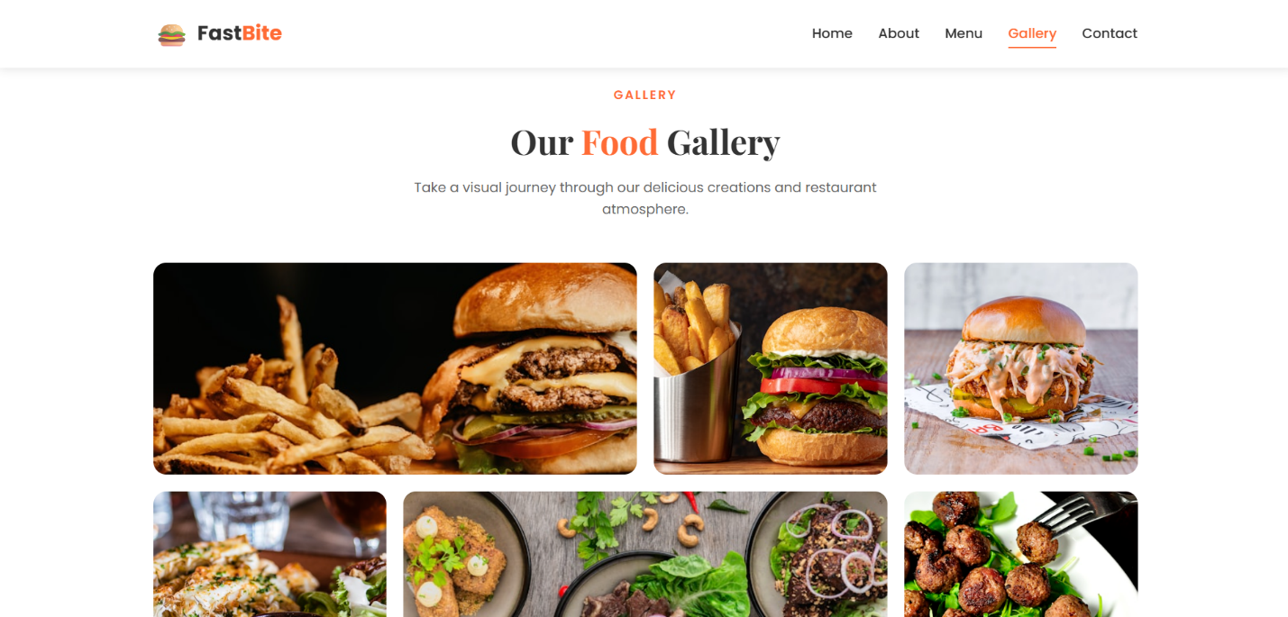

Contact Page:
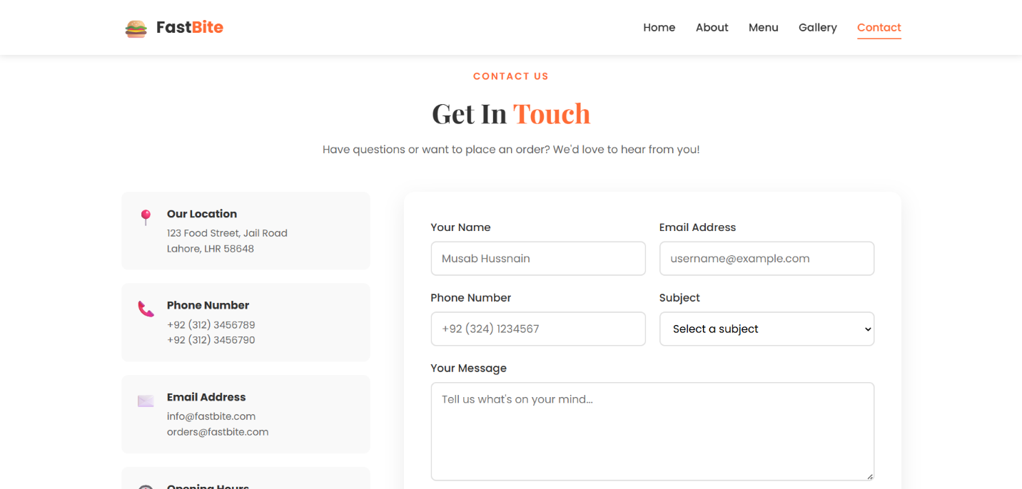

Live Website Link:
To Preview the live website click the link here. FastBite

How to run website?
To run the Online Restaurant website, first ensure that all project files, including HTML files, CSS files, images, and assets, are stored in the same main project folder with proper subfolders (such as CSS and images). Open the main file, usually named index.html, using any modern web browser such as Google Chrome, Microsoft Edge, or Mozilla Firefox by double-clicking it or using the “Open with” option. Since the project is developed using HTML and CSS only, no additional software, server, or internet connection is required to run the website locally. The navigation bar allows users to move between pages like Home, Menu, About Us, Gallery, and Contact smoothly, ensuring proper functionality across desktop and mobile screens.

Reflections (What was learned, improvements)
Through this project, we learned the fundamentals of front-end web development, including the practical use of HTML for structuring web pages and CSS for styling, layout design, and responsiveness. We improved our understanding of navigation systems, responsive layouts using Flexbox or media queries, and the importance of clean design choices such as fonts, colors, and spacing. This project also enhanced our teamwork, planning, and documentation skills. As a future improvement, the website can be extended by adding backend functionality such as online ordering, user accounts, and payment integration. Additionally, JavaScript can be introduced to improve interactivity, animations, and form validation, making the website more dynamic and user-friendly.

